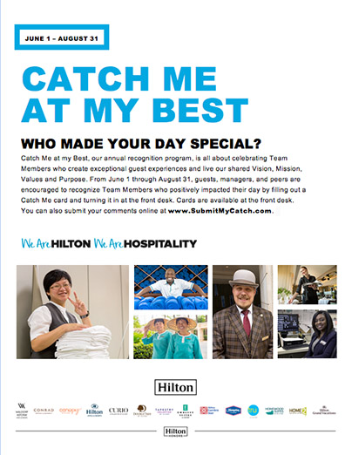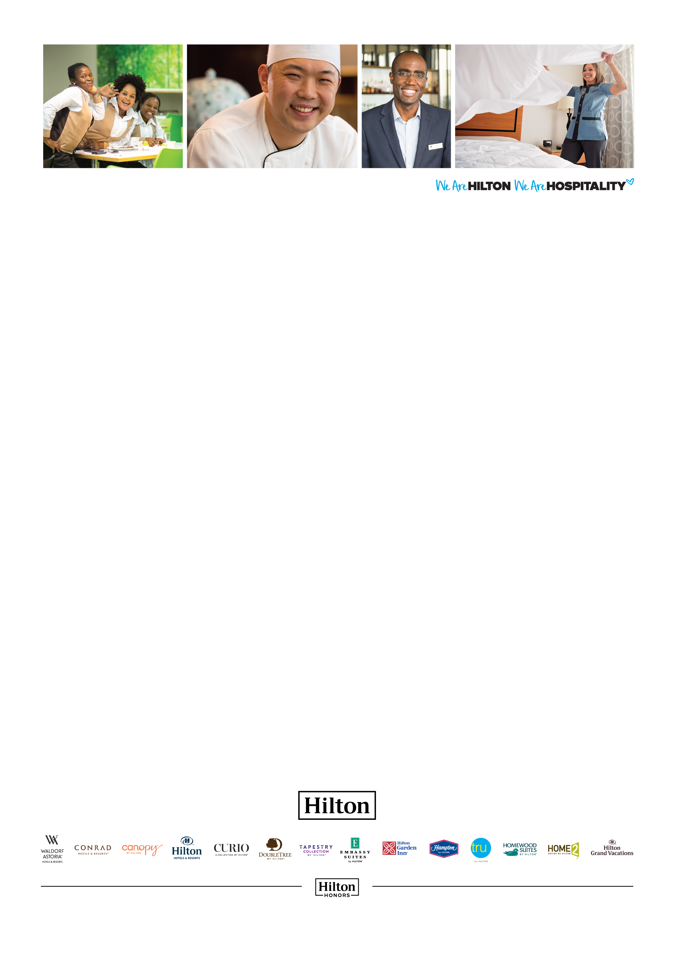

PROMOTE GUEST CATCHES AT YOUR LOCATION

Like any successful recognition initiative, Catch Me at My Best requires some effort to create awareness among Guests and Team Members. Simply leaving cards at the front desk isn’t always enough. Use the poster on the following page to let Guests know about Catch Me at My Best. Print and display throughout your location. You can even place in Guest rooms. All content is customizable, including fonts and language.

The headline font is Arial Black, which is standard on many computers. If you don’t have Arial Black, we recommend you use a sans serif font in a similar bold weight.

CATCH ME

AT MY BEST

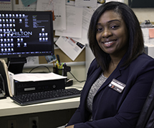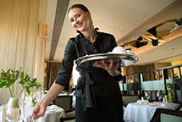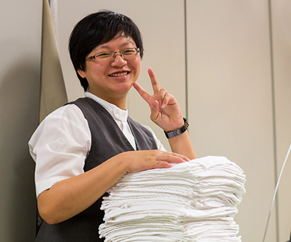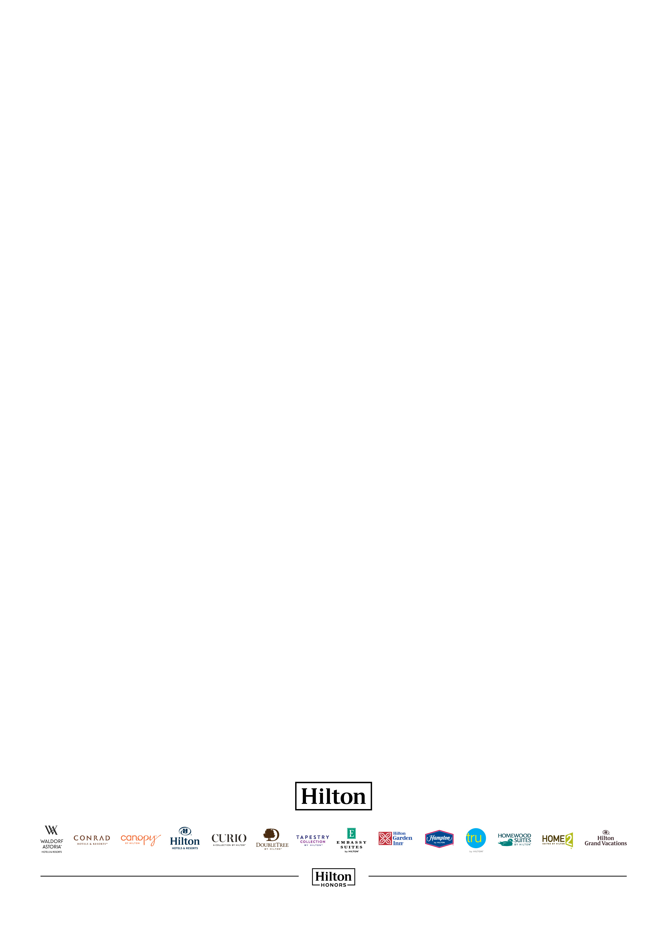

WHO MADE YOUR DAY SPECIAL?

Catch Me at my Best, our annual recognition program, is all about celebrating Team Members who create exceptional Guest experiences and live our shared Vision, Mission, Values and Purpose. From June 1 through August 31, Guests, managers, and peers are encouraged to recognize Team Members who positively impacted their day by filling out a Catch Me card and turning it in at the front desk. Cards are available at the front desk.   
You can also submit your comments online at www.SubmitMyCatch.com.

CATCH ME

AT MY BEST

JUNE 1 – AUGUST 31