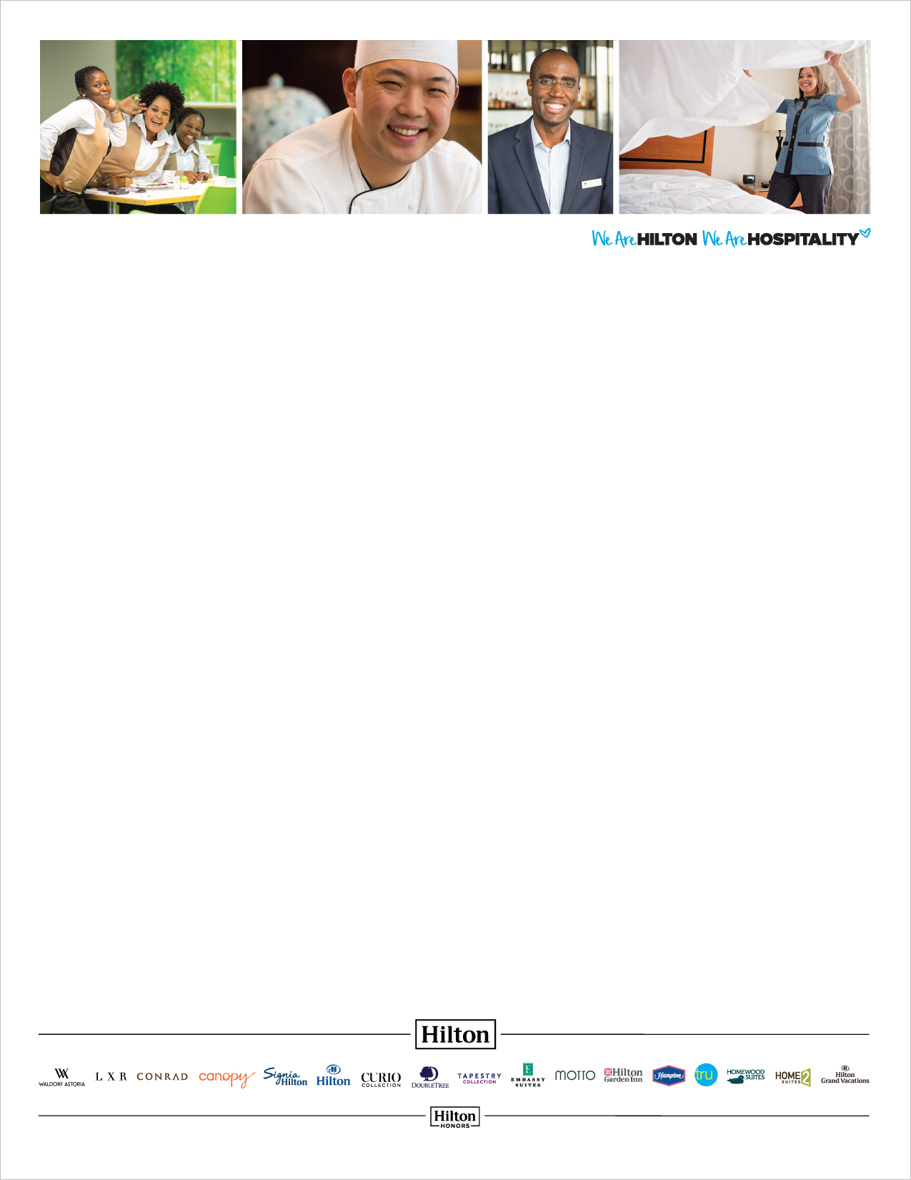

CATCH ME INSTRUCTION SHEET

(PLEASE NOTE THE FOLLOWING BEFORE POSTING / DISTRIBUTING: SEVERAL COMMENTS HAVE BEEN INCLUDED BELOW IN RED. THESE WILL NEED CLARIFICATION FROM YOU. PLEASE EDIT AND/OR DELETE ACCORDINGLY. ADDITIONALLY, ALL CONTENT IS EDITABLE. YOU CAN ADD CUSTOM CONTENT OR TRANSLATE THE COPY.)

WHAT IS CATCH ME AT MY BEST?

Every day at our hotel, Team Members display countless acts of Hospitality that positively impact Guests and fellow Team Members alike. Catch Me at My Best is a Team Member recognition program created to recognize these acts, and reinforce our founder Conrad Hilton’s vision to “fill the earth with the light and warmth of hospitality.”

WHEN IS CATCH ME?

The annual program runs from June 1 to August 31.

HOW DOES CATCH ME WORK?

When a Guest, manager, or teammate wants to recognize a Team Member, they simply fill out a Catch Me card and turn it in. This is called a “catch.” The cards are available at the front desk. Guests and Team Members can also catch each other online by visiting www.SubmitMyCatch.com.

(NOTE TO USER: ADD SPECIFICS ABOUT HOW YOUR HOTEL WILL RECOGNIZE CATCHES.)

WHO CAN BE CAUGHT?

Any Team Member, including managers.

WHO CAN MAKE A CATCH?

Anyone! Guests, managers, and fellow Team Members. That includes you.

WHAT IS CATCH-WORTHY?

The exact criteria are up to you and the Guest. However, we encourage managers and Team Members to catch their coworkers for acts of Hospitality, big or small, that positively impact Guests, teammates, the hotel, or the community.

CATCH ME

AT MY BEST



* WOWing a Guest
* A perfect room inspection
* Resolving a Guest or hotel issue
* Pitching in to help another department
* A positive comment card
* Working a late shift
* Community service
* Remembering a Guest’s name (or preference)
* Saving the hotel money
* Helping you carry a heavy box

WHY SHOULD I PARTICIPATE IN THIS PROGRAM?

Because recognizing others feels good, and it’s the right thing to do. It also aligns with our core value of Hospitality. And if that’s not enough incentive, we are offering prizes to participants.

TELL ME MORE ABOUT THE PRIZES.

Over 30 Catch Me participants from across all Hilton properties will be selected to receive a USD $50 gift card. We will select 10 winners in June, 10 winners in July, and 10 winners in August, based on whether or not a Team Member made or received a catch. The total number of catches made or received will NOT be taken into account when selecting winners. So a Team Member with one catch has the same chance of winning as a Team Member with 20 catches.

In addition to company prizes, (NOTE TO USER: ADD SPECIFICS ABOUT PRIZES SPECIFIC TO YOUR LOCATION HERE.)

IS CATCH ME JUST ABOUT NUMBERS?

No. Whether you’ve received one catch or 100, every catch is special and should be celebrated.

HOW DO I GET STARTED?

Beginning June 1, grab a card and go catch a fellow Team Member!

“Today, Chef Michael went the extra mile to purpose lactose-free milk for a guest when he noticed   
that the guest had special dietary restrictions.”

WHAT SHOULD I KNOW ABOUT WRITING A CATCH?

There’s only one rule about writing a catch: Be specific about the act. For example:

“Recently, during a busy weekend, Jason took initiative to come in on his day off to help. He is definitely a team player, and we really appreciate his help!”

“I saw Minnie go out of her way to pick up trash in the hallway today. She has set a great example for all of us to always make sure that we have a clean working environment.”

For example, you could catch a Team Member for any of the following: