
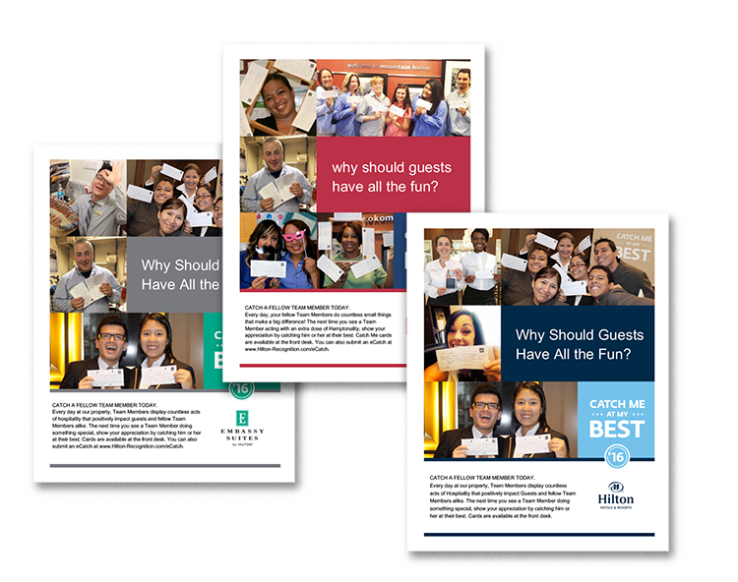
June 1 – August 31, 2016

Promote Peer Catches at Your Location

When surveyed last year, almost 25% of hotels said that catches were submitted by guests only!
Hotels that get the most out of Catch Me place an equal emphasis on getting enthusiasts to catch each other. Use the poster on the following page to promote peer catches. Print and display in your
break room, by your time clock, and in other common areas. All content is customizable, including fonts and language.

CATCH ME AT MY BEST

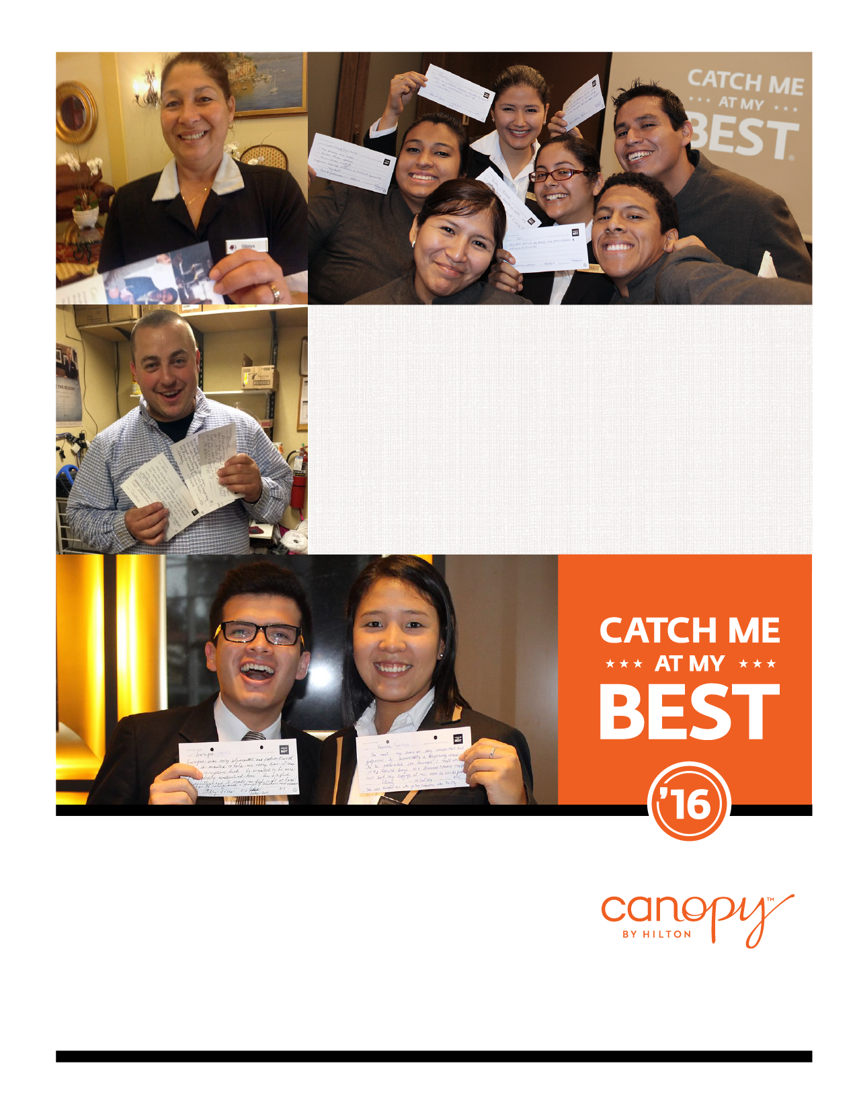

Why Should Guests Have All the Fun?
CATCH A FELLOW ENTHUSIAST TODAY.
Every day at our property, enthusiasts display countless acts of hospitality that positively impact guests and fellow enthusiasts alike. The next time you see an enthusiast doing something special, show your appreciation by catching him or her at their best. Cards are available at the Welcome Desk. You can also submit an eCatch at www.Hilton-Recognition.com/eCatch.

