
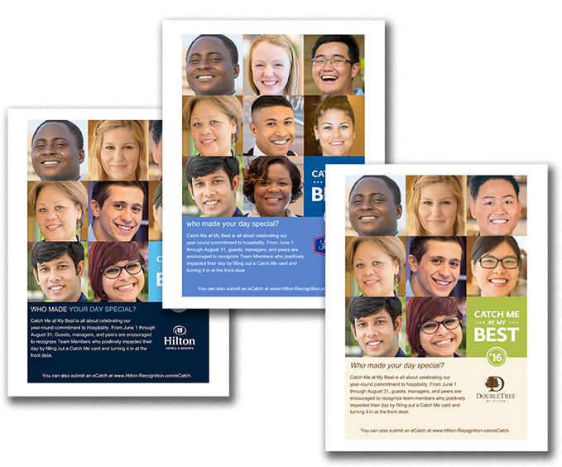
Build Internal Awareness About Catch Me at My Best

Use the poster on the following page to promote internal awareness among Team Members. Print and display in your break room, by your time clock, or in other team common areas. All content is customizable, including fonts and language. Please note that this poster is intended for internal use only.

You can also download a Back of House poster to encourage your team to catch back-of-house
Team Members.

June 1 – August 31, 2016

CATCH ME AT MY BEST

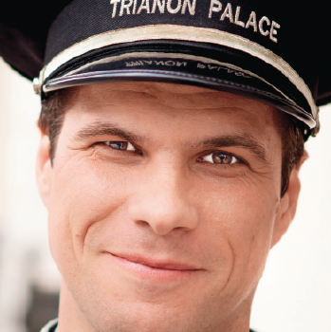






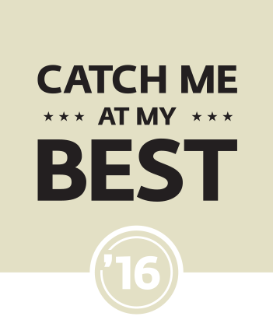




WHO MADE YOUR DAY SPECIAL?

The Catch Me at My Best peer recognition program is all about celebrating our year-round commitment to hospitality. From June 1 through August 31, managers and peers are encouraged to recognize Team Members who positively impacted their day by filling out a card and turning it in to Human Resources.

You can also submit an eCatch at www.Hilton-Recognition.com/eCatch.

