
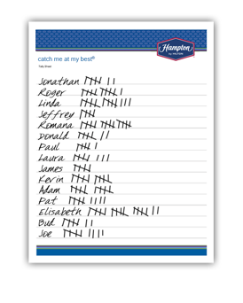
catch me at my best

June 1 – August 31, 2016

Tally Sheet

Use this as a supplement to the online Tally Website to help keep track of who’s being caught. Pass out
to other managers, so they can keep track of results within their department. MAKE SURE ALL TALLY SHEETS ARE TURNED IN AND ENTERED INTO THE TALLY WEBSITE.

Helpful tip: If you’re looking for a larger Tally Sheet, you can try printing the 11" x 17" or A3 version. Or, try taking the file to a local copy center and have them print an even larger version.



catch me at my best

Tally Sheet



