
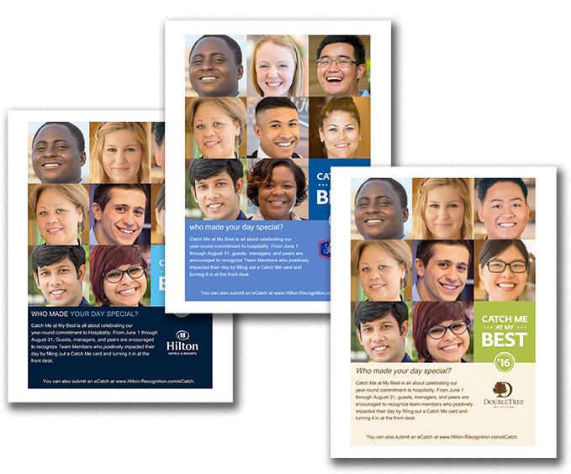
Build Internal Awareness About Catch Me at My Best

Use the poster on the following page to promote internal awareness among enthusiasts. Print and display in your break room, by your time clock, or in other common areas. All content is customizable, including fonts and language. Please note that this poster is intended for internal use only.

June 1 – August 31, 2016

CATCH ME AT MY BEST









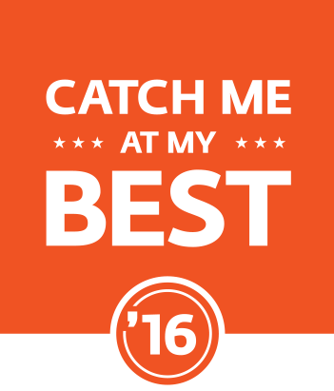


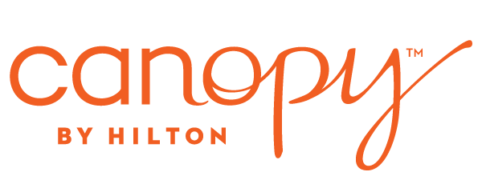
Who made your day special?

Catch Me at My Best is all about celebrating our
year-round commitment to hospitality. From June 1 through August 31, guests, Leads, and peers are encouraged to recognize enthusiasts who positively impacted their day by filling out a Catch Me card and turning it in at the Welcome Desk.

You can also submit an eCatch at www.Hilton-Recognition.com/eCatch.

